*Use the information in Chapter 16 (p.305-322) to answer the following questions about DNA and replication. You may also find the following Bozeman podcasts useful:* [*Nucleic Acids*](http://www.bozemanscience.com/nucleic-acids)*,* [*DNA & RNA Part 1*](http://www.bozemanscience.com/027-part-1-dna-rna)*,* [*DNA & RNA Part 2,*](http://www.bozemanscience.com/027-part-2-dna-rna)[*Meselson-Stahl Experiment*](http://www.bozemanscience.com/meselson-stahl-experiment)*, and* [*DNA Replication*](http://www.bozemanscience.com/dna-replication)*.*

**Concept 16.1: DNA is the Genetic Material**

Describe the experiment performed by each of the following groups of researchers and for each explain how their research contributed to our understanding of DNA.

|  |  |  |
| --- | --- | --- |
| **Researcher Group** | **Experiment** | **Contribution** |
| Frederick Griffith |  |  |
| Oswald Avery, Maclyn McCarty, & Colin McLeod |  |  |
| Alfred Hershey & Martha Chase |  |  |
| Erwin Chargaff |  |  |
| Rosalind Franklin, James Watson, Francis Crick |  |  |

Refer to Figure 16.5 (p.308) to label the following diagrams.

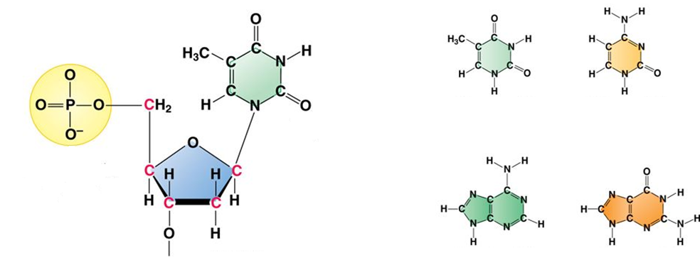

Refer to Figure 16.7 (p.309) to label the following diagram and answer the questions that follow.

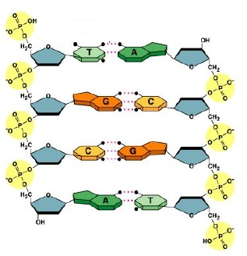

Why is DNA said to be an antiparallel molecule?

Why does a pyrimidine always pair with a purine?

**Concept 16.2: Many proteins work together in DNA replication and repair**

Which model of DNA replication did Meselson & Stahl’s research support? Explain.

Use Figure 16.2 (p.313) compare and contrast prokaryotic and eukaryotic replication.

|  |  |  |
| --- | --- | --- |
| **Prokaryotic** | **Both** | **Eukaryotic** |
|  |  |  |

Identify and explain the function of the following structures/enzymes that are involved in DNA replication using Figure 16.13 the diagram below.

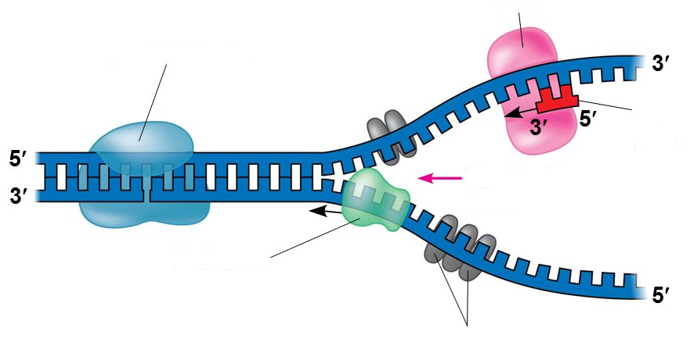

Use Figure 16.14 (p.315) and the below diagram to explain the function of DNA polymerase and why we say that each DNA strand has directionality.

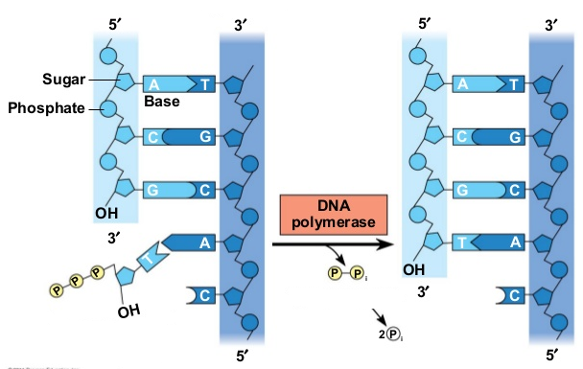

Draw a diagram for and discuss the major differences between how the leading and lagging strand are synthesized during replication.

Describe the various ways that DNA is proofread and repaired after replication and the evolutionary significance of errors that go uncorrected.

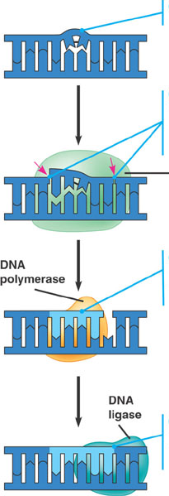

Discuss how telomeres provide a protective function for important genes and the role of telomerase in eukaryotic germ cells.